***Hands-On Exercise 3.1 [20-points]: Connecting Nodes Manually***

### *Instructions:*

***IDE structure:***

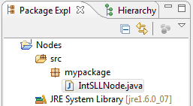

1.❑ Type the code below and get it to work.

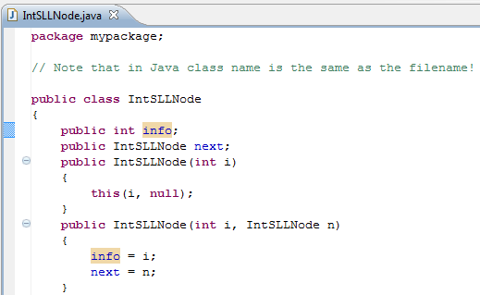

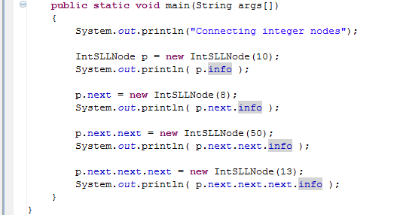

2.❑ Paste your code here.

3.❑ Paste your screen shot output here [Ctrl] + [PrtScn]. Make sure you magnified it.

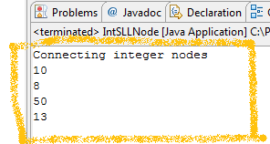Similar to this output

4.❑ Add another node with int value of -12, paste below the code that you added and paste the new output.

5.❑ Write your topmost question regarding this topic.

6.❑ **Critical Thinking:** If you are asked to make a test question based on this topic, what would be the question and what is your answer?

**Submission Procedure**

1. Write your **name** here: __________________________
2. Date: __________________________
3. **Backup** your work to your USB drive, this material may come out as part of your exam.
4. **Submit** to Blackboard at the link where you got it.

**Note:**

* Submit back to Blackboard where you get it.
* 2-points deduction if you submit it on the wrong place.
* 2-points deduction if you did not follow these instructions.
* Make sure you submit it at the correct location where you got it.

|  |  |  |  |  |
| --- | --- | --- | --- | --- |
| GRADING RUBRIC | | | | |
| Grading Criteria | 3  **Exceeds**  *Excellent*  Epic Wow | 2  **Meets**  *Satisfactory*  O.K. | 1  **Partially Meets**  *Below Expectations*  Not Yet | 0  **Does Not Meet**  *Unacceptable*  Fail |
| **Completeness** | +5-Completed all the required work and added more examples. | +2-Completed all the work required. | +1-Partially completed the work required. | Unfortunately, did not complete the work required. |
| **Coding** | +10- Code is excellent, comments are added, and different techniques were used. | +7-Code is O.K., and program works. | +4-Code works, but still needs improvement. | Unfortunately, no coding. |
| **Output** | +5-Outputs are correct, and provided additional output cases. | +2-Output meets requirement and is readable. | +1-There is output, but not readable, and/or needs improvement. | Unfortunately, no output. |
| **Late** | Excellent, you submitted it before the deadline. | -5, unfortunately for submitting after the deadline. | -7, unfortunately for submitting several weeks after the deadline. | -10, unfortunately, for submitting very late. |